HW2 report

Bicheng Xu

# Task 1:

Nll plot for [-2,-1,0,1]

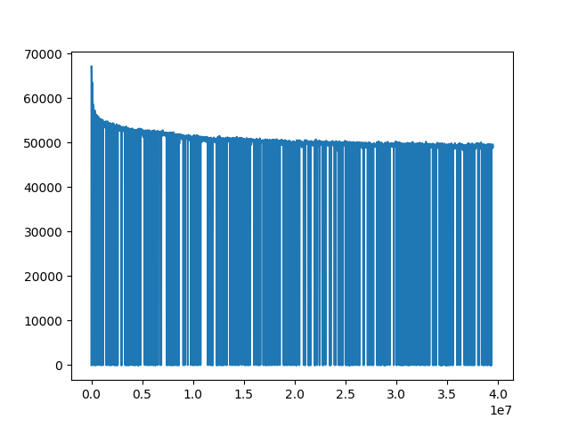

Nll plot for [1,2,3,4] and for [-4,-3,-2,-1]

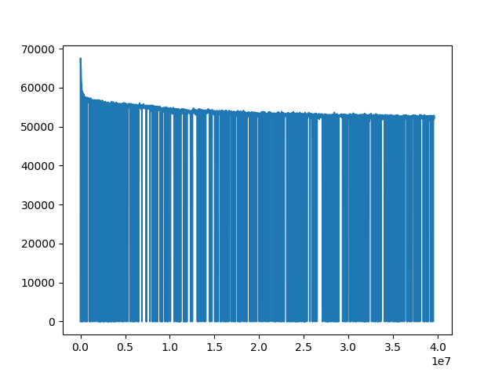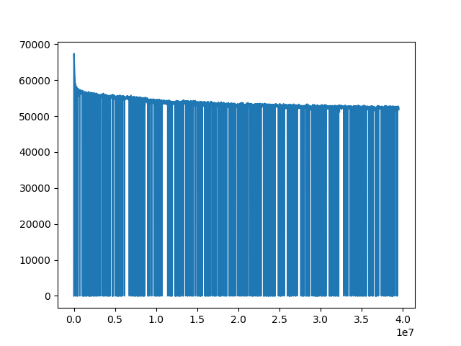

Conclusion: the final nll result is [-2,-1,0,1] better than [-4,-3,-2,-1] better than [1,2,3,4]; however, generally they produce very similar results.

# Task 3

|  |  |  |  |  |  |  |  |  |
| --- | --- | --- | --- | --- | --- | --- | --- | --- |
|  | **[-2,-1,1,2]** |  |  | **[-4,-3,-2,-1]** |  |  | **[1,2,3,4]** |  |
| target_word | similar_word | similar_score | | similar_word | similar_score | | similar_word | similar_score |
| **good** | **good** | **1** |  | **good** | **1.00** |  | **good** | **1.00** |
| good | interesting | 0.54 |  | hope | 0.46 |  | nice | 0.54 |
| good | decent | 0.53 |  | crappy | 0.45 |  | decent | 0.50 |
| good | terrific | 0.52 |  | outstanding | 0.44 |  | pleasant | 0.48 |
| good | fun | 0.51 |  | overshadowed | 0.44 |  | fine | 0.47 |
| good | passable | 0.51 |  | enjoyed | 0.44 |  | bad | 0.47 |
| good | nice | 0.48 |  | watchable | 0.43 |  | pretty | 0.46 |
| good | okay | 0.47 |  | liked | 0.43 |  | guys | 0.46 |
| good | fine | 0.47 |  | promise | 0.42 |  | ass | 0.46 |
| good | pleasant | 0.46 |  | okay | 0.42 |  | movie.. | 0.45 |
| **bad** | **bad** | **1.00** |  | **bad** | **1.00** |  | **bad** | **1.00** |
| bad | lousy | 0.55 |  | uninspired | 0.55 |  | good | 0.47 |
| bad | sucks | 0.52 |  | inept | 0.53 |  | fault | 0.47 |
| bad | frankly | 0.51 |  | terribly | 0.52 |  | loved | 0.46 |
| bad | abysmal | 0.49 |  | embarrassing | 0.52 |  | unfortunately | 0.44 |
| bad | ugh | 0.48 |  | weak | 0.51 |  | acting | 0.43 |
| bad | acting | 0.48 |  | ridiculous | 0.51 |  | sloppy | 0.43 |
| bad | poor | 0.47 |  | thin | 0.50 |  | irritating | 0.43 |
| bad | crappy | 0.47 |  | ok. | 0.50 |  | tho | 0.43 |
| bad | horrible | 0.47 |  | bland | 0.50 |  | problem | 0.42 |
| **scary** | **scary** | **1.00** |  | **scary** | **1.00** |  | **scary** | **1.00** |
| scary | creepy | 0.62 |  | creepy | 0.55 |  | creepy | 0.55 |
| scary | terrifying | 0.59 |  | gory | 0.54 |  | scarier | 0.54 |
| scary | spooky | 0.58 |  | unsettling | 0.53 |  | eerie | 0.52 |
| scary | eerie | 0.56 |  | neat | 0.50 |  | menacing | 0.51 |
| scary | frightening | 0.55 |  | frightening | 0.49 |  | playful | 0.48 |
| scary | freaky | 0.55 |  | eerie | 0.49 |  | shocking | 0.47 |
| scary | atmospheric | 0.55 |  | suspenseful | 0.49 |  | cool | 0.47 |
| scary | disturbing | 0.51 |  | low-budget | 0.47 |  | strange | 0.46 |
| scary | tongue-in-cheek | 0.51 |  | freaky | 0.46 |  | menace | 0.46 |
| **funny** | **funny** | **1.00** |  | **funny** | **1.00** |  | **funny** | **1.00** |
| funny | amusing | 0.63 |  | witty | 0.58 |  | hilarious | 0.52 |

I label the results which I don’t think is good in red. For [-2,-1,1,2], most of the prediction is satisfying, however, while the prediction of the other twos have many unrelated or even opposite results. Thus, the prediction of training model with [-2,-1,1,2] is much better than the others. I guess this this because context words on both sides can give more information about the center word.